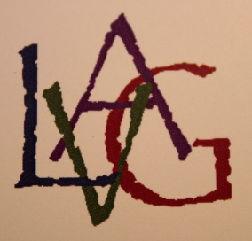
LONDON VISUAL ARTS GUILD
STUDIO 7
VOL. 2 MARCH 2017 NO.2

SPRING 2017 ART CLASSES
The current art classes have been scheduled from March 1st through May 31st. Those interested in attending a class should contact the instructor. You should also verify the price and the number of students who will be allowed to register for that class. Some classes have limits on size. A list of classes ending on May 31st is listed on page two.
FOUNDERS SHOW
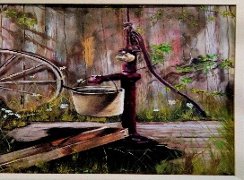
A list of LVAG founders is on page two with a short history of how the London Visual Arts Guild was created. Be sure to read that section. A couple paintings from the Founders Show. 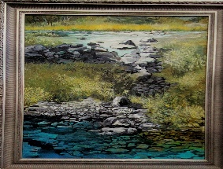
GEORGE BUSH’S BOOK
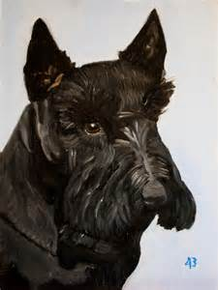
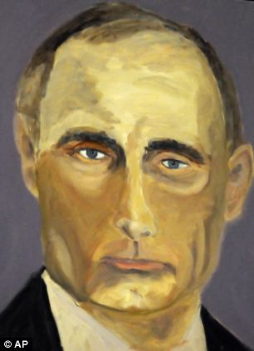
As I watched the news banner run on TV this morning George W. Bush was introduced as a guest on the show. The appearance was to promote a group of paintings he had done. They were published in book form. Samples were shown and most were quite good.
His art career began after leaving the presidency. He needed a hobby for relaxation and painting was suggested. He bought the necessary equipment, found an instructor and his new career began. Two of his paintings are above. -------------------------------------------------------------------
This brought to mind another statesman who turned to art during his career as a rewarding way to relax from his relentless job.
One day he procured a child’s paint box to familiarize himself with materials needed to create paintings. The next day he went out and purchased a complete outfit in oils and stayed in that medium the remainder of his life.
At that period of his life he had no time for lessons or tutoring and very little time for painting. He was busy with affairs of state but did manage to spend a few minutes each day with brush in hand and a canvas before him.
At the end of his career he decided to spend his free time with his new-found love of creating pictures with canvas and oil paints.
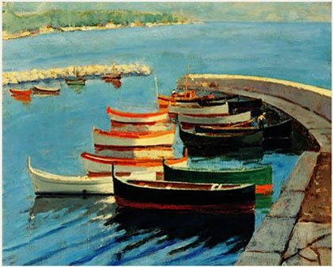
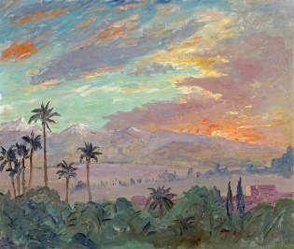
During the forty-eight-years he painted he created more than 500 paintings in various detail and sizes. Below are two of the paintings created by Winston Churchill.
________________________________________
REMINDER
London Visual Arts Guild is a 501- C3 organization and is not a storefront sales gallery. Therefore, one of our money raising projects is the collection of aluminum cans. So if possible drop off your aluminum at 5 E High during the open hours of the gallery.
Also watch for special events. We expect Blue Grass entertainment to return this fall.

GALLERY HOURS
Thurs 11am – 2pm
Sat 10am – 2pm
Sun 11am – 2pm
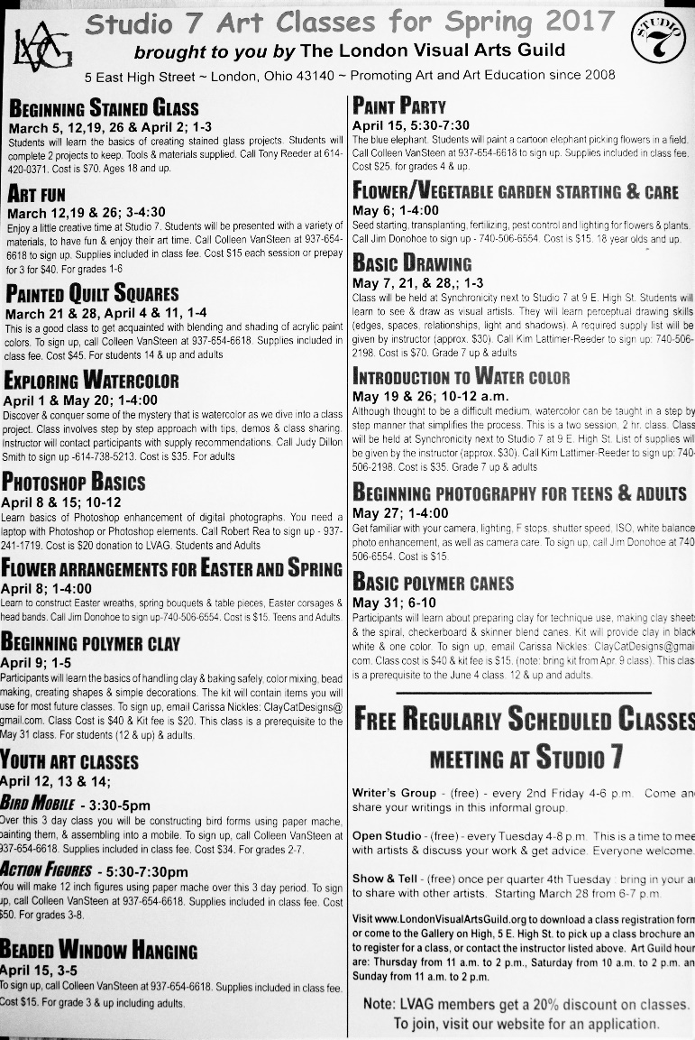
Studio 7 is open 4pm – 8pm every Tuesday for those who wish to have one-on-one instruction. A member of LVAG will be on hand to help with problems or questions.
_____________________________________________
FOUNDERS SHOW
A HISTORY OF LVAG
Early in 2008 the London Methodist Church formed Visions of Hope, a community development 501-C3 organization under the direction of Pastor Steve Rogers. The church was creating Lift Up On High to sponsor apartments for unwed mothers in a portion of the building the Minner Family allowed Visions of Hope to use. There were two storefronts as well and Kim Reeder suggested that community artists could use those for an art gallery called Gallery on High. Steve approached The Artists of Madison County. That organization was not interested, but a group of artists within it was. This group formed a new organization called the London Visual Arts Guild (LVAG).
Alice Seyfried Payne and Tom Keen focused on creating the LVAG organization and defining how it would interact with Visions of Hope and with Pastor Steve Rogers. The rest of the group worked on remodeling the two storefronts into gallery On High and Studio 7. The people were: Mary Andrix, Nancy Bindas, Sharon Bracket, Harry Croghan, Marjorie Foulk, Sondra Fox, Jim Keen, Kay Majka, John Pyles, Bob Rea, Kim Reeder, Steve Rogers and Don Swenson.
In the fall of 2008, the first member show was held and since then over 90 shows have been hosted in the gallery. It took longer to get Studio 7 ready to use, but we have used that for community classes, our meetings and open studio, on Tuesdays, from 4 until 8 for anyone in the community to work on their art and socialize.
The March 2917 show is the Founders Show. We are honoring Jim Keen, who left our presence last fall after a bout with cancer. Included in his many gifts to LVAG are the stained-glass signs in the gallery on High and Studio 7. He will be missed.
London Visual Arts guild is a 501-C3 organization operating solely on its own.

LONDON VISUAL ARTS GUILD NEWSLETTER
Is the sole property of the London Visual Arts Guild and Studio 7 housed at 5 & 7 E. High St. London, Ohio. LVAG owns the copyright to all material in this publication. The material in the LVAG newsletter may be used in any publication once permission has been obtained from LVAG
EDITOR: Jim Donohoe 740-506-6554
Ohkrill4@yahoo.com / ohkrill4@gmail.com

